**MSIS 2602 Information Systems Analysis & Design**

**Project: Know Your DNA**



**Guided by Professor:**

**Dr. Yasser Dessouky**

**Submitted By:**

**Faliha Zikra**

**Mytreyi Reddy**

**Sri Ananya Kondiparthy**

**Apoorva Revankar**

**Table Of Contents**

1. Business description

2. Business Need

3. Business Requirements

4. Business Value

5. How this system will support operations

6. Project Plan

7. Functional Requirements

8. Non- Functional Requirements

9. Use Cases

10. Data Flow Diagrams

11. Structure Chart

12. Data Dictionary

13. UI Mockup

14. Future Work

15. Conclusion

**KnowYourDNA**

**Business Description**

KnowYourDNA provides a direct-to-consumer genetic testing service in which customers provide a [saliva sample](https://en.wikipedia.org/wiki/Saliva_testing) that is [laboratory analyzed](https://en.wikipedia.org/wiki/SNP_genotyping). It helps people access and understand their genome better by offering advanced DNA reports that deliver:

* An enriching view of a person’s ancestry that helps discover their family history.
* In-depth information about genetic predispositions to health risks, wellness, and physical traits.

Customers have a choice to share this information with their primary healthcare provider who is then able to:

* Suggest lifestyle changes for a better outcome.
* Order more tests for further screening, if needed.

|  |
| --- |
| **System Request: KnowYourDNA Ordering and Reporting System** |
| **Business Need:**  DNA sequencing a few years ago cost over billions of dollars and took years to get results. With the advent of Cloud computing and faster microprocessors, processing, and sequencing DNA information has become much easier and cheaper. From $1000 dollars in 2008, the price of DNA sequencing has fallen drastically to $100 dollars today.  The main purpose of this system “KnowYourDNA” is it sequences key information from the DNA and maps it to prior ancestral databases as a commercial service to the end-user via a web interface. There are current services that do provide ancestry and wellness information. But unfortunately, most of them are caught up in legalities due to FDA regulations and are unable to provide “not- sugar-coated” findings to their customers. This application, however, can be linked with your primary care doctor who can view and access the actual risk associated with the test results and better educate the customer about their test results or recommend tests or therapy routes to them. |
| **Business Requirements:**  Using the system, the customers can understand their genetic makeup better and take proactive health measures by involving their physicians early on. The specific functionalities the system must have are as follows:   * The system will grant access privileges based on the roles of the user, for eg, ‘Physician’, ‘ User’. * The system will display the user’s Ancestry information pertaining to the geographical origin of the User. * The system will inform the user about the risk associated (in terms of presence or absence of certain genes) with the User’s genetic predispositions to 25+ health conditions. * The system will show in-depth information with regards to population statistics about the User’s genetic predispositions to 25+ health conditions. * The system will show in in-depth information about their likelihood of developing 25+ physical traits and 7 wellness traits. * The system will enable the user to send the health reports to his primary care provider with the user’s consent. * The system will allow the primary health care physician to look at the user’s test results more elaborately. * The system will facilitate the primary health care physician to prescribe additional genetic tests to the user if required. |
| **Business Value:**  As the detailed health-related characteristics would be specified, the customer can identify the areas of improvement and could work on it. This system not only has a return on investment (ROI), but it also has a return on value (ROV).   * An electronic record of the user’s genetic makeup that can be reviewed anytime by the user or his physician. * It helps improve users’ awareness and understanding of their DNA and its risk implications which helps them make more informed choices that may relate to healthy living. * Comprehensive genetic testing highlights health risks that might help with early-on detection of risks which otherwise might not surface for years, therefore improving user’s health outcomes by 15%. * Improves early-on communication and interaction between the user and their primary care physician proactively which helps educate the user further. * Encourages lifestyle changes and preventative measures prior to the incidence of health risks by 15 to 20%. |
| **How the system will support operations:**   * Ease of ordering the tests * Ease of viewing wellness and ancestry information on one portal * Ability to send their reports to the physician within the system with ease * The ability of physicians to review the reports and request additional tests. * Tracking the orders (Starting Process from samples to generating reports and sending to physicians) |

**Functional Requirements**

|  |
| --- |
| 1. **The system should allow a user (customer/physician) to create an account.**   **Process Requirements:**   * 1. The system should allow the user to create an account with their personal information like name and email.   2. The system should update the user information in the Customer/Physician Data Store.   3. The system should allow the user to enter their email address.   4. The system should allow users to enter their passwords.   5. The system should check for validity in terms of the strength of the password.   6. The system should update the username and password in the Customer Data Store.   7. The system should allow users to create an account with their approval.   8. The system should update the Customer/Physician Data Store (either physician or customer) with their account details.   9. The system should generate a confirmation for the user account creation.   **Information Requirements:**   * 1. The system should the user’s personal information in the Physician/Customer Data Store.   2. The system should store the email ID and password of the user in the Physician/Customer Data Store.   3. The system should contain the user’s account information in the Physician/Customer Data Store. |
| 1. **The system should allow the customer to order a kit.**   **Process Requirements:**   * 1. The system should display the catalog of kits available for the customer to choose from.   2. The system should allow the customer to select from Wellness or Ancestry and Wellness kits.   3. The system should allow the customer to enter their shipping address.   4. The system should display the total order price.   5. The system should allow the customer to enter their payment details.   6. The system should allow the customer to confirm their purchase.   7. The system should validate the payment details through a credit card clearinghouse.   8. The system should update the order details in the Order Data Store, after payment.   9. The system should update the shipping information in the Order Data Store.   10. The system should display order receipt to the customer.   **Information Requirements:**   * 1. The system should contain the images, description, price, and details of both the kits.   2. The system should contain the customer’s shipping address.   3. The system must contain order information once the order is finalized. |
| 1. **The system should allow the processing of the order by the clerk.**   **Process Requirements:**   * 1. The system should display the order information for the clerk to process the order.   2. The system should allow the clerk to generate a UPS tracking number for shipping.   3. The system should allow the clerk to update the order information with the tracking number.   4. The system should store the updated order information.   **Information Requirements:**   * 1. The system should contain the tracking number associated with the order.   2. The system should contain the updated order information after the clerk has processed the order. |
| 1. **The system should allow the processing of the order by the geneticist.**   **Process Requirement:**   * 1. The system should display the customer’s order information to the geneticist.   2. The system should display the list of up- to date traits that the geneticist should analyze the sample for.   3. The system should allow the geneticist to update the customer’s order to indicate they have started working on it.   4. The system should store the updated order information.   5. The system should allow the geneticist to update the wellness information in the Wellness Data Store.   6. The system should store the customer’s wellness information in the Wellness Data Store.   7. The system should allow the geneticist to update the ancestry information in the Ancestry Data Store.   8. The system should store the customer’s ancestry information in the Ancestry Data Store.   **Information Requirement:**   * 1. The system should contain a list of all the up to date traits to be sequenced.   2. The system should contain the customer’s wellness reports.   3. The system should contain the customer’s ancestry reports.   4. The system should contain the updated information of the customer’s order after it has been processed by the geneticist. |
| 1. **The system should display a personalized user dashboard for the customer.**   **Process Requirement:**   * 1. The system should allow customers to select either their ancestry, wellness or statistical information.   2. The system should display the customer’s ancestry, wellness or statistical report.   3. The system should allow customers to send the report to the physician.   4. The system should allow customers to add their physician’s information.   5. The system should prompt the customer to grant permission to use their payment details.   6. The system should allow customers to approve the request.   7. The system should update the customer order with the physician’s details.   **Information Requirement**:   * 1. The system should contain the customer’s ancestry information.   2. The system should contain the customer’s wellness information.   3. The system should contain the customer’s statistical information.   4. The system should contain updated customer order information with the physician’s information. |
| 1. **The system should display a personalized user dashboard for the physician**   **Process Requirement**:   * 1. The system displays a list of the physician’s customers and their information.   2. The system should allow the physician to choose the patient whose report they want to view.   3. The system should allow the physician to access the patient’s personalized report.   4. The system should display the patient’s detailed wellness report.   5. The system should notify the customer that their physician has seen their report.   6. The system should display additional tests the physicians can order from.   7. The system should allow the physician to select tests to be ordered.   8. The system should allow the physician to confirm the ordering of these tests.   9. The system should update the order information in the Order Data Store and creates a new order in the Physician Order Data Store.   10. The system should send a notification to the customer about the additional test orders being placed.   **Information Requirements**:   * 1. The system should contain a list of physician’s patients.   2. The system should contain the physician’s patient information.   3. The system should contain the physician’s patient wellness report.   4. The system should contain a list of additional tests the physician can order from.   5. The system should contain the physicians’ test order information.   6. The system should contain updated customer order information with additional test information. |
| **Non-Functional Requirements:**   1. **Operational Requirements:**   1.1 The system should be able to work on any Web browser.  1.2 The system should be able to run on mobile devices.  1.3 The system will log-off after a 10-minute timeout session.  1.4 The system should be able to integrate with the credit card clearing system.  1.5 The system should be able to integrate with the third-party shipper UPS.     1. **Performance Requirements:**   2.1 The system should be available 24 hours per day, 365 days per year.  2.2 Interaction between the user and the system should not exceed 3 seconds.  2.3 The system should be able to support 100 simultaneous users at all times.     1. **Cultural and Political requirements:**   3.1 Personal information is protected in compliance with the Data Protection Act.  3.2 The system should accept USD as the currency for transactions.     1. **Security Requirements:**   4.1 The system should authorize Clerks to make updates to the Order Data Store.  4.2 The system should authorize Geneticists to make updates to the Wellness and Ancestry Data Store.  4.3 The system should validate every user’s credentials during login.  4.4 The Physician should not be given access to view the Ancestry information of his/her patient.  4.5 User information should be accessed only by authorized personnel like Clerk, Geneticists. |

**Use Cases**

Blue: Input to the system

Orange: Output of the system

**Use Case 1**

|  |  |  |  |  |  |
| --- | --- | --- | --- | --- | --- |
| **Use Case Name:** User creates an account | | | | **ID: UC-1** | **Priority: High** |
| **Brief Description:** User creates an account | | | | | |
| **Actor:** User | | | | | |
| **Trigger:** The User wants to create an account to access their dashboard.  **Type: External** Temporal | | | | | |
| **Preconditions:** | | | | | |
| **Normal Course**   1. The user enters personal information like first and last names to initiate account creation (Alternative Course 1). 2. The system stores the user’s personal information in the corresponding data store. 3. The user enters the email address (Exception 2). 4. The user chooses a password. (Exception 3). 5. The system checks for password strength. 6. The system stores the user’s email address and password. 7. The user approves the creation of the account. 8. The system stores the user’s account information. 9. The user receives a receipt confirming new account creation. | | | **Information for Steps**  Personal Information    Personal Information  Email address  Password  Approval of Password strength  Email address and password  Approval for account creation  Account information  Confirmation of account creation | | |
| **Alternative Course(s):**   1. The customer already has an account.    1. The system requests that the actor enter his/her name and password.    2. The actor enters his/her name and password (Exception 1).    3. The system validates the entered name and password and logs the actor into the system. | | | | | |
| **Postconditions:**   1. The user logs in to the system. | | | | | |
| **Exceptions:**   1. The User ID and password entered is invalid.    1. An error message is displayed.    2. The user can type in a new name or password or choose to cancel the operation. 2. The username is already taken.    1. The user is prompted to choose another username. 3. The Password doesn’t match the strength criteria.    1. The customer is notified and asked to choose another password. 4. The passwords don’t match.    1. An error message is displayed and the user is prompted to try again. | | | | | |
| **Summary:**  **Inputs Source Outputs Destination** | | | | | |
| Personal information | User | Personal Information | | | Customer/Physician Data Store |
| Email Address | User | Email Address and Password | | | Customer/Physician Data Store |
| Password | User | Approval of Password strength | | | User |
| Approval for account creation | User | Account information | | | Customer/Physician Data Store |
|  |  | Confirmation of account creation | | | User |

**Use Case 2**

|  |  |  |  |  |  |
| --- | --- | --- | --- | --- | --- |
| **Use Case Name:** Place an order | | | | **ID: UC-2** | **Priority: High** |
| **Brief Description:** The customer can place an order for a wellness or wellness and ancestry kit. | | | | | |
| **Actor:** Customer | | | | | |
| **Trigger:** The customer wants to order a genetic testing kit.  **Type: External** Temporal | | | | | |
| **Preconditions:**   1. The customer should have logged into the system and been validated. | | | | | |
| **Normal Course**   1. The system shows the customer the details of the kit. 2. The customer selects the kit of preference. 3. The system shows the customer the total of their order. 4. The customer fills in payment information. 5. The customer fills in the shipping information. 6. The customer confirms the purchase of the order (Alternative course 1). 7. The system validates the customer’s payment information (Exception 1). 8. The system stores the customer’s order and shipping information in the Order Data Store. 9. The customer receives an order receipt | | | **Information for Steps**    Details and cost of the kit  Kit of Preference    Total price order  Payment information  Shipping information  Confirmation to purchase  Payment authorization  Payment validation  Order information  Shipping information  Order receipt | | |
| **Alternative Course(s):**   1. The customer changes his mind and wants to order the alternative kit.    1. Repeat steps 1-3 | | | | | |
| **Postconditions:**   1. The customer order starts to be processed. | | | | | |
| **Exceptions:**   1. The payment information is invalid.    1. An error message is displayed.    2. The customer is asked to fill in their payment details again. | | | | | |
| **Summary:**  **Inputs Source Outputs Destination** | | | | | |
| Details and cost of the kit | Customer | Payment authorization | | | CC clearing house |
| Kit of Preference | Customer | Order information | | | Order Data Store |
| Total price order | Item Data Store | Order receipt | | | Customer |
| Payment information | Customer | Shipping information | | | Order Data Store |
| Confirmation to purchase | Customer |  | | |  |
| Shipping information | Customer |  | | |  |
| Payment validation | CC clearing house |  | | |  |

**Use Case 3**

|  |  |  |  |  |  |
| --- | --- | --- | --- | --- | --- |
| **Use Case Name:** Processing the Orders: Clerk | | | | **ID: UC-3** | **Priority: High** |
| **Brief Description:** The order is processed by the clerk who sends the kit to the customer through UPS. | | | | | |
| **Actor:** Clerk | | | | | |
| **Trigger:** The clerk wants to ship the saliva kit to the customer.  **Type: External** Temporal | | | | | |
| **Preconditions:**   1. The customer has placed the order. | | | | | |
| **Normal Course**   1. The system displays the clerk the customer order. 2. The clerk generates tracking information through UPS. 3. The system sends tracking information to the customer. 4. The clerk updates the order information. 5. The system stores the updated order. | | | **Information for Steps**    Order information  Tracking information  Tracking information  Updated order  Updated order | | |
| **Alternative Course(s):** | | | | | |
| **Postconditions:**   1. The system should assign a geneticist to this order. | | | | | |
| **Exceptions:** | | | | | |
| **Summary:**  **Inputs Source Outputs Destination** | | | | | |
| Order information | Order Data Store | Tracking information | | | Customer |
| Tracking information | Clerk | Updated order | | | Order Data Store |
| Updated order | Clerk |  | | |  |

**Use Case 4**

|  |  |  |  |  |  |
| --- | --- | --- | --- | --- | --- |
| **Use Case Name:** Processing the Orders: Geneticist | | | | **ID: UC-4** | **Priority: High** |
| **Brief Description:** The order is then processed by the geneticist who sequences the sample for results. | | | | | |
| **Actor:** Geneticist | | | | | |
| **Trigger:** The geneticist receives the customer sample and wants to sequence it.  **Type: External** Temporal | | | | | |
| **Preconditions:**   1. The customer has sent back the saliva sample for sequencing. 2. A geneticist has been assigned to this order. | | | | | |
| **Normal Course**   1. The system displays the customer order information. 2. The system shows the list of up- to date traits that the geneticist should analyze the sample for. 3. The Geneticist updates the customer order to indicate they have started working on it. 4. The system stores the updated order information. 5. The Geneticist report the wellness information. 6. The system stores the customer’s wellness information. 7. The Geneticist reports the customer’s ancestry information. 8. The system stores the customer’s ancestry information. | | | **Information for Steps**  Order information  List of traits  Updated order  Updated order  Wellness Results  Wellness Results  Ancestry Results  Ancestry Results | | |
| **Alternative Course(s):** | | | | | |
| **Postconditions:**   1. The system should alert the customer that their results are ready for viewing. | | | | | |
| **Exceptions:** | | | | | |
| **Summary:**  **Inputs Source Outputs Destination** | | | | | |
| Order information | Order Data Store | Updated order | | | Order Data Store |
| List of traits | Traits Master Data Store | Wellness Results | | | Wellness Data Store |
| Updated order | Geneticist | Ancestry Results | | | Ancestry Data Store |
| Wellness Results | Geneticist |  | | |  |
| Ancestry Results | Geneticist |  | | |  |

**Use Case 5**

|  |  |  |  |  |  |
| --- | --- | --- | --- | --- | --- |
| **Use case Name:** Customer dashboard | | | | **ID: UC-5** | **Priority: High** |
| **Brief Description:** The customer is able to see his/her personalized dashboard that contains his/her ancestry, wellness, and statistical information. | | | | | |
| **Actor:** Customer | | | | | |
| **Trigger:** The customer wants to see their genetic information.  **Type: External** Temporal | | | | | |
| **Preconditions:**  1. The customer should be logged in.  2. The customer should have purchased a kit and the customer’s sample should have been processed. | | | | | |
| **Normal Course**   1. The customer requests to see their ancestry information (Alternative Course 1, Alternative Course 2). 2. The system displays the customer’s ancestry report. 3. The system customer requests to send the report to the physician. 4. The customer adds the physician’s information. 5. The systems prompt the customer to grant permission to use their payment details. 6. The customer approves the request. 7. The system updates the customer order with the physician’s details. | | | **Information for Steps**    Request to access    Ancestry information  Ancestry information  Request to send report to Physician  Physician Information  Prompt to seek permission for using the payment information  Approval to use payment information  Updated Order with Physician Details | | |
| **Alternative Course(s):**   1. The customer requests to see their ancestry information.    1. The system displays the customer’s wellness report. 2. The customer requests to see their statistical information pertaining to the variants found.    1. The system displays the statistical report. | | | | | |
| **Postconditions:**   1. The system sends out an email to the physician of the customer. | | | | | |
| **Exceptions:** | | | | | |
| **Summary:**  **Inputs Source Outputs Destination** | | | | | |
| Request to access | Customer | Ancestry information | | | Customer |
| Ancestry information | Ancestry Data Store | Prompt to seek permission for using the payment information | | | Customer |
| Request to send report to Physician | Customer | Updated Order with Physician Details | | | Order Data Store |
| Physician Information | Customer | Wellness Information | | | Customer |
| Approval to use payment information | Customer | Statistical Information | | | Customer |
| Wellness Information | Wellness Data Store |  | | |  |
| Statistical Information | Statistical Data Store |  | | |  |

**Use Case 6**

|  |  |  |  |  |  |
| --- | --- | --- | --- | --- | --- |
| **Use case Name:** Physician dashboard | | | | **ID: UC-6** | **Priority: High** |
| **Brief Description:** The physician is able to see his/her personalized dashboard with reports of his patients and can order additional tests if required. | | | | | |
| **Actor:** Physician | | | | | |
| **Trigger: T**he physician wants to review the report of their patients and/or order additional tests**.**  **Type: External** Temporal | | | | | |
| **Preconditions:**   1. The physician should be logged in. 2. The customer should have agreed to share the reports with the physician. | | | | | |
| **Normal Course**   1. The system displays a list of the physician’s customers and their information. 2. The Physician chooses the patient whose report they want to view. 3. The Physician requests to access the patient’s personalized report. 4. The system displays the patient’s detailed wellness report. 5. The system notifies the customer that their physician has seen their report. 6. The system displays additional tests the physicians can order from. 7. The Physician selects tests to be ordered (Alternative Course 1). 8. The Physician confirms the ordering of these tests. 9. The system updates the order information in the Order Data Store and creates a new order in the Physician Order Data Store. 10. The system sends a notification to the customer about the additional test orders being placed. | | | **Information for Steps**  List of patients  Patient information  Patient of choice  Request to access a detailed report  Customer’s Wellness report  Patient’s wellness report  Notification that Physician has viewed the test results  List of Additional tests  List of selected tests  Confirmation for placing order  Updated order information  Physician Order information  Notification of additional tests ordered | | |
| **Alternative Course(s):**   1. The physician does not find the test he is looking for.    1. The physician returns to the dashboard. | | | | | |
| **Postconditions:**   1. The geneticist will be notified of the additional test orders. | | | | | |
| **Exceptions:** | | | | | |
| **Summary:**  **Inputs Source Outputs Destination** | | | | | |
| List of patients | Customer Data Store | Patient’s wellness report | | | Physician |
| Customer information | Customer Data Store | Notification that Physician has viewed the test results | | | Customer |
| Patient of choice | Physician | Updated order information | | | Order Data Store |
| Request to access a detailed report | Physician | Physician Order information | | | Physician Order Data Store |
| Customer’s Wellness report | Wellness Data Store | Notification of additional tests ordered | | | Customer |
| List of Additional tests | Traits Data Store |  | | |  |
| Confirmation for placing order | Physician |  | | |  |

**Data Flow Diagrams**

**Context Diagram**

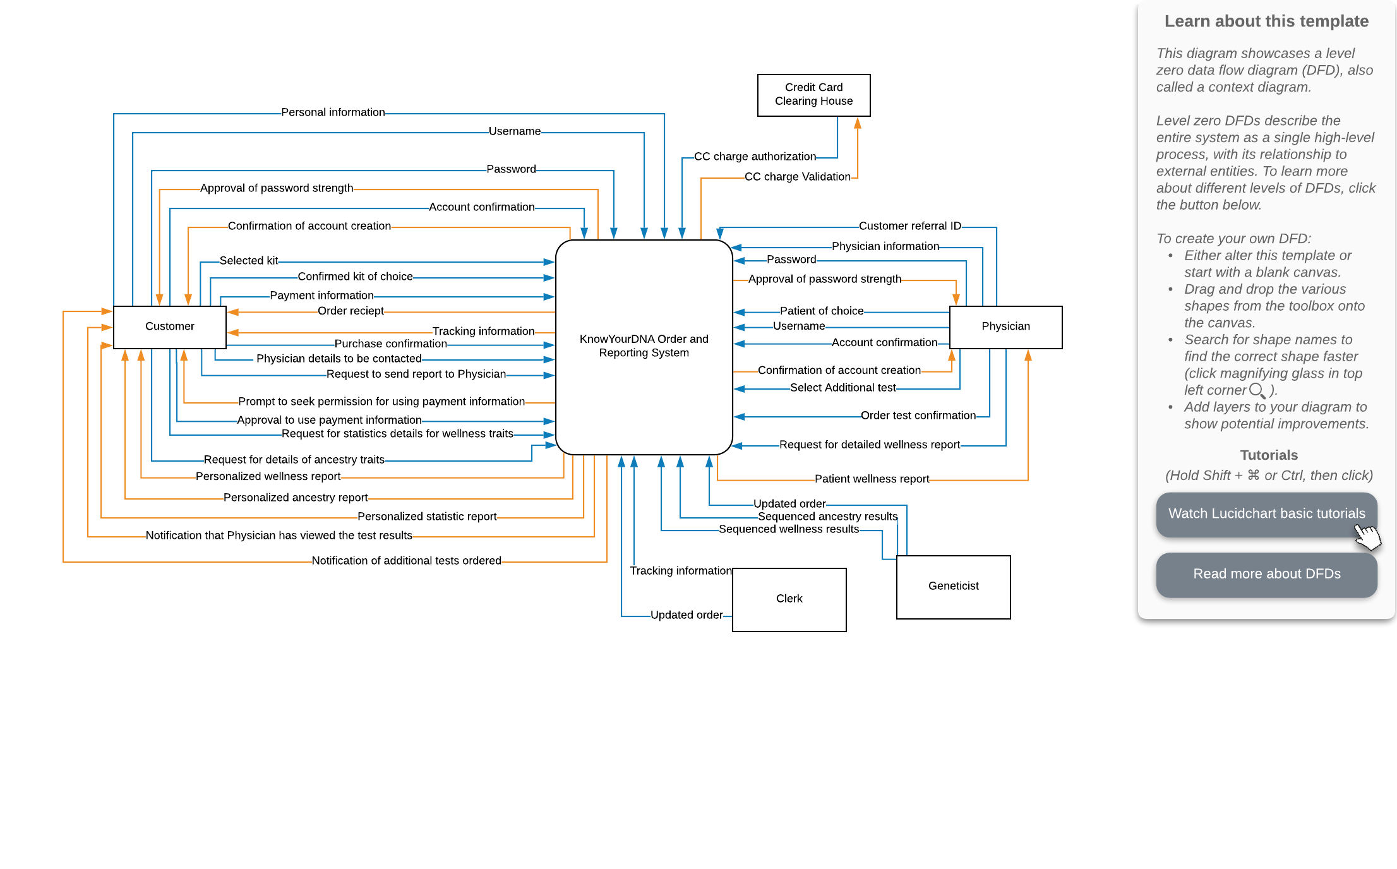

**Level 0 Diagram**

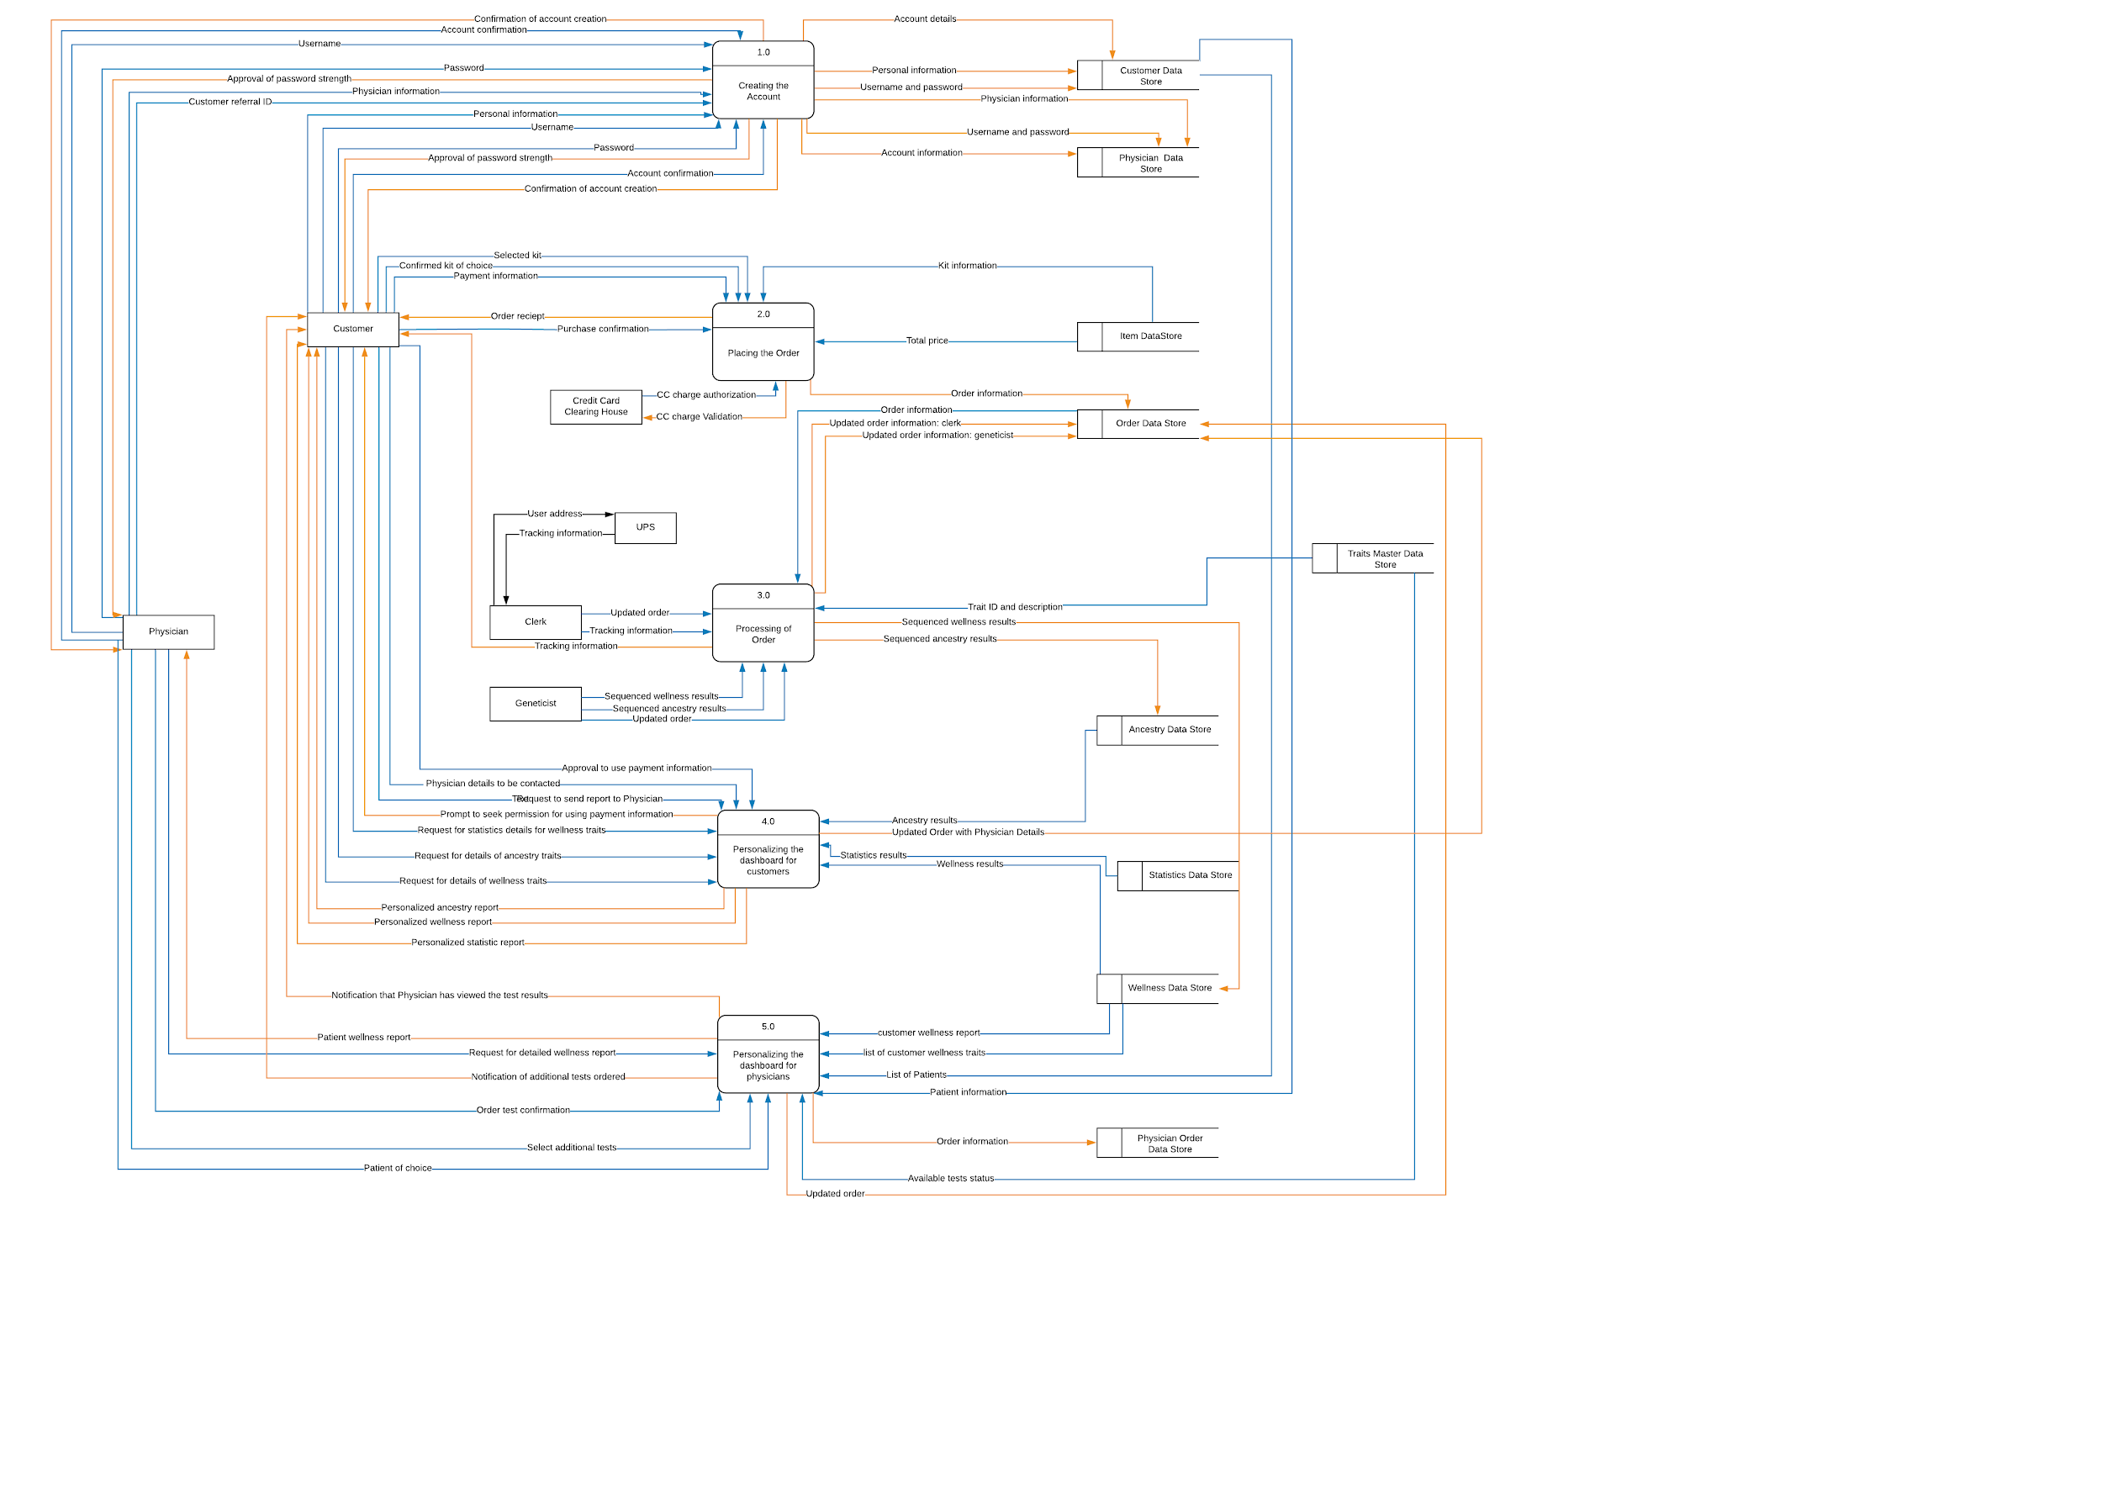

**Level 1 Diagram**

**1: Creating an account** 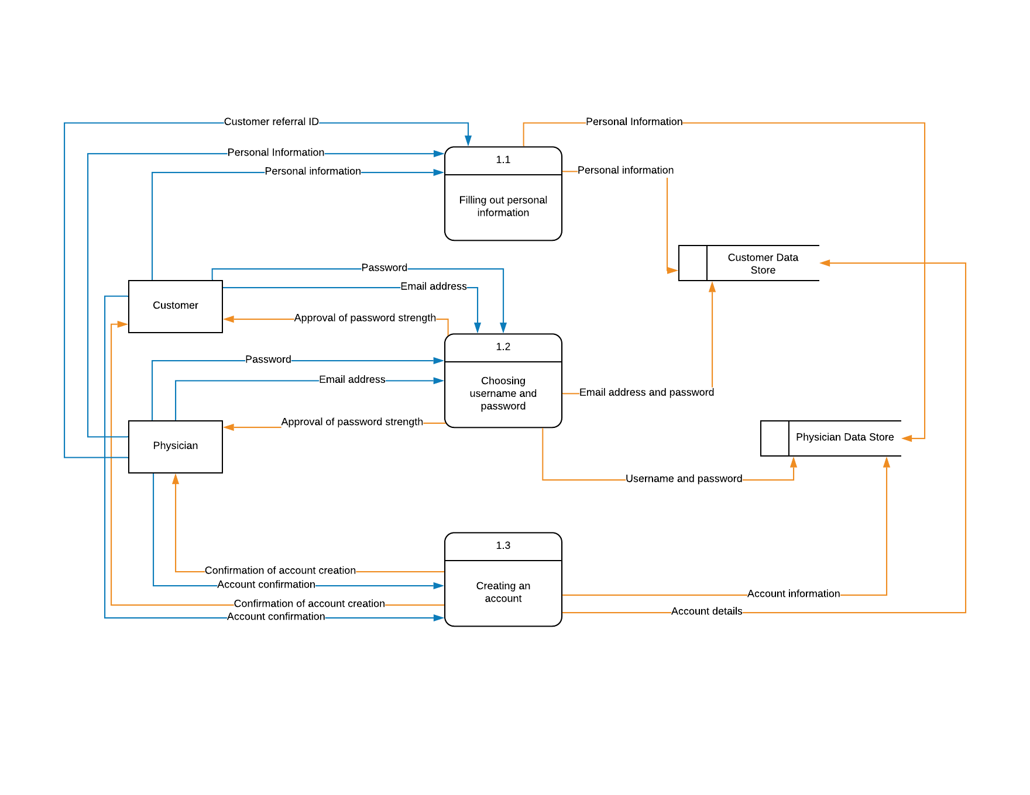

**2: Placing an order**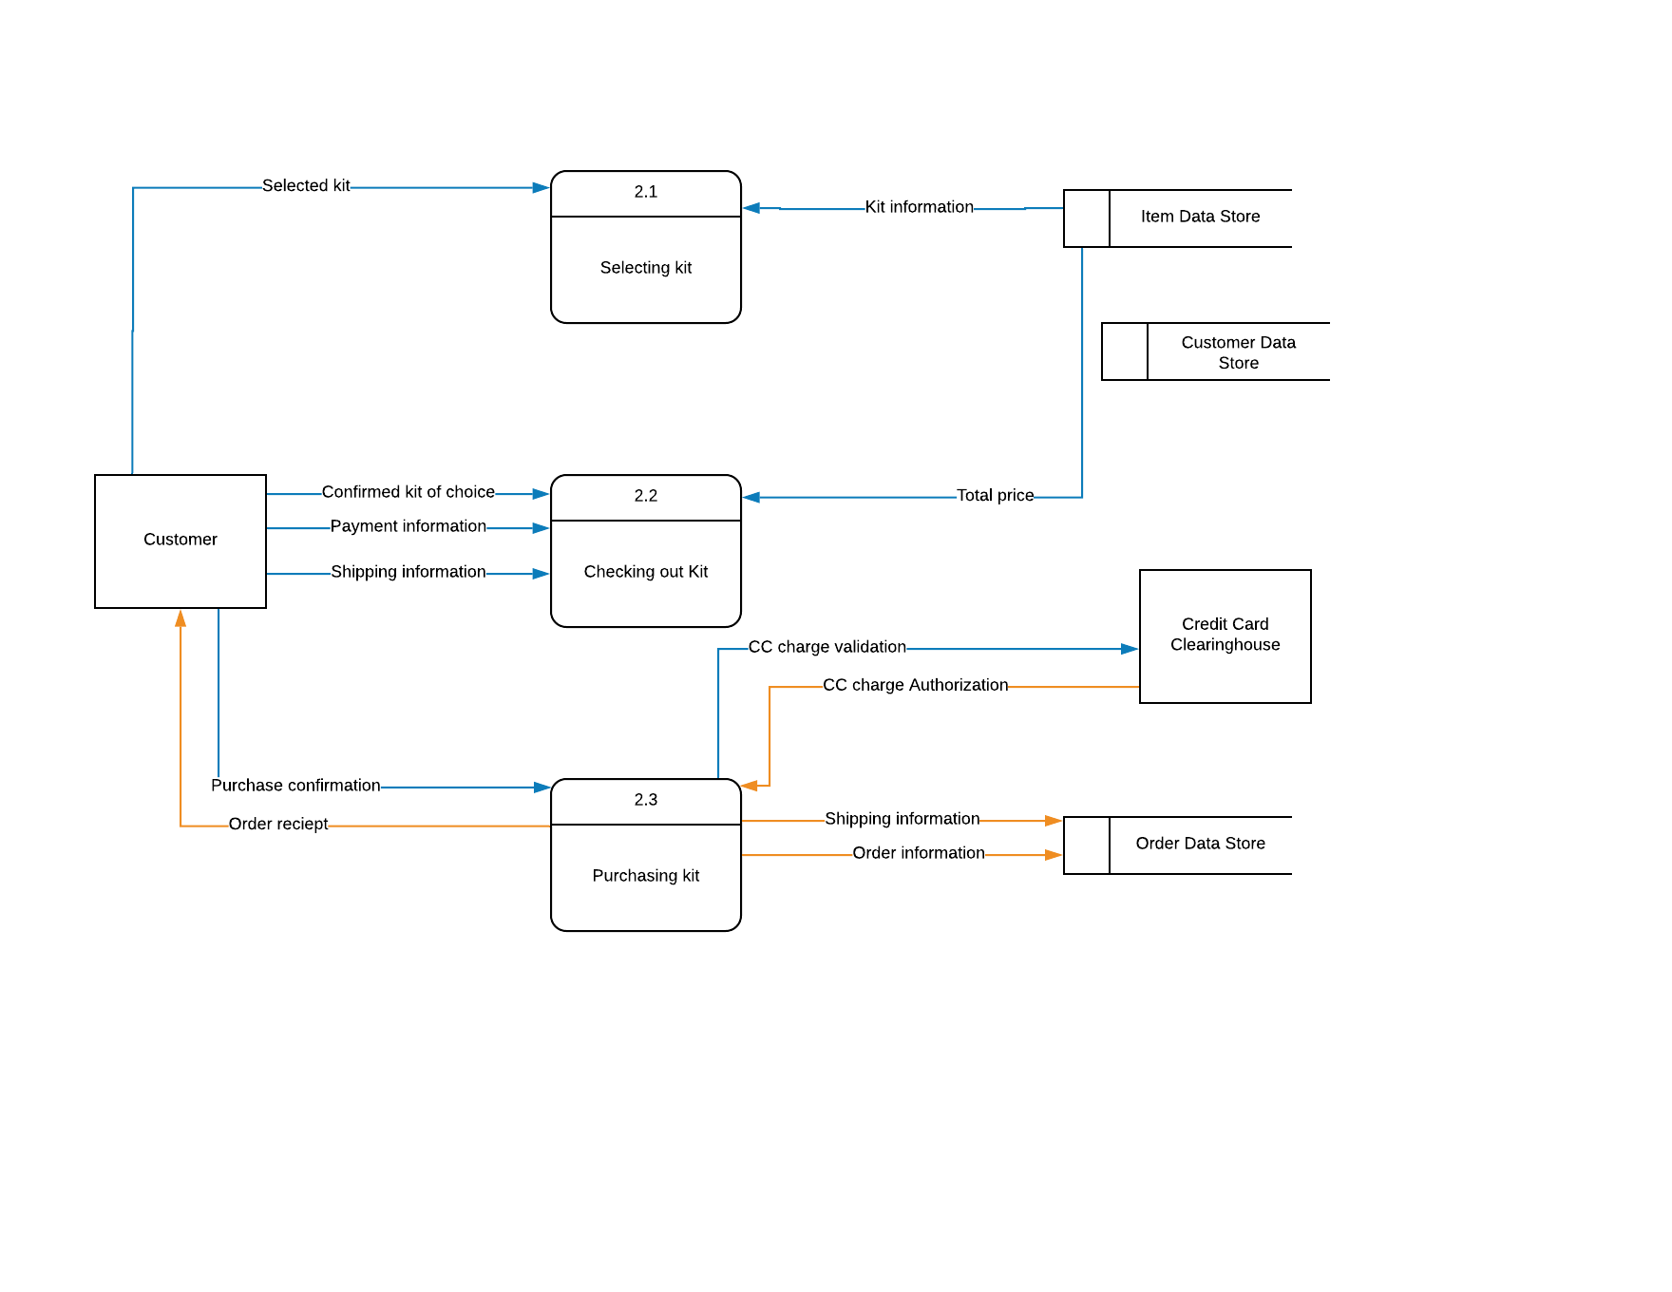

**3: Processing of the Order by Clerk and Geneticist**

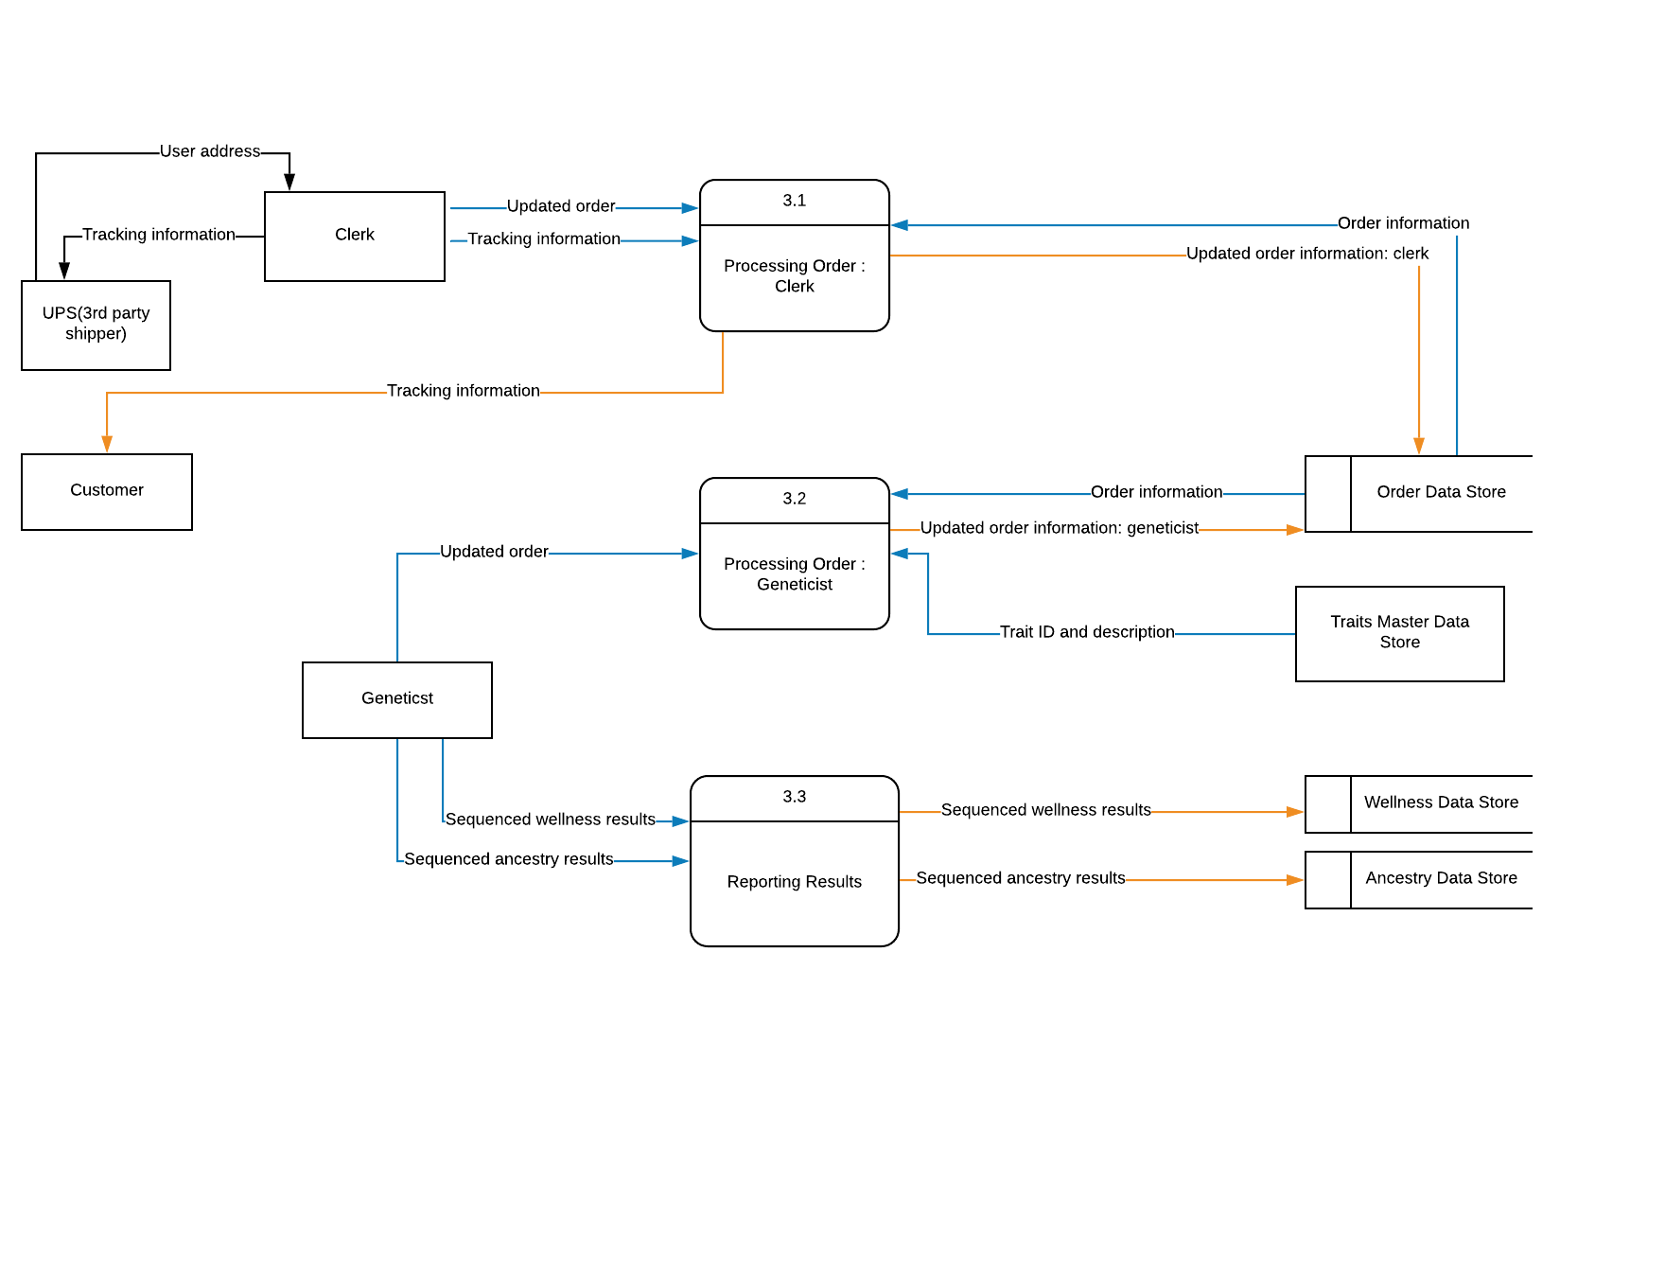

**4: Displaying personalized Dashboard to the user**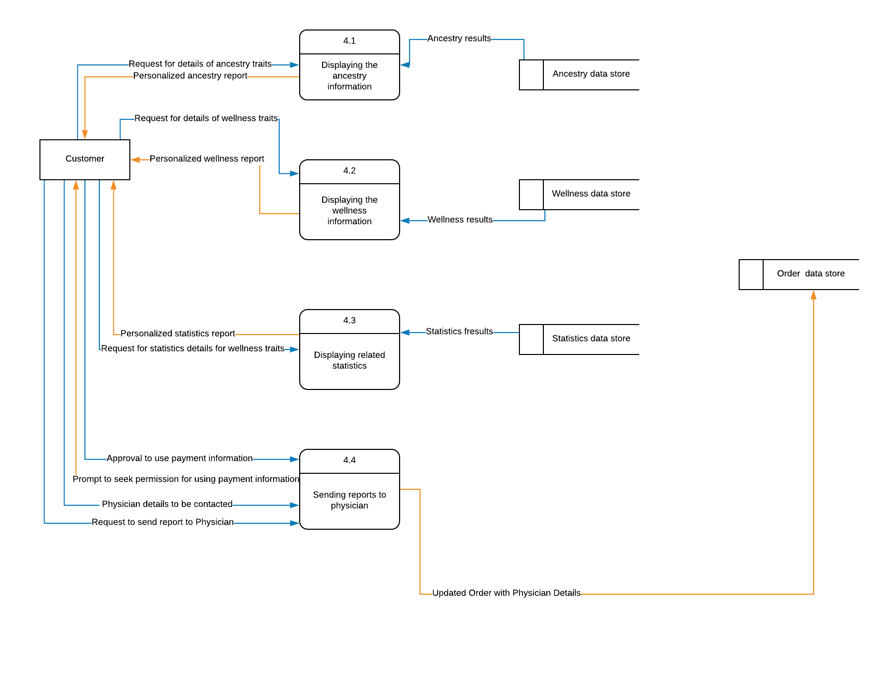

**5: Displaying personalized dashboard to the physician**

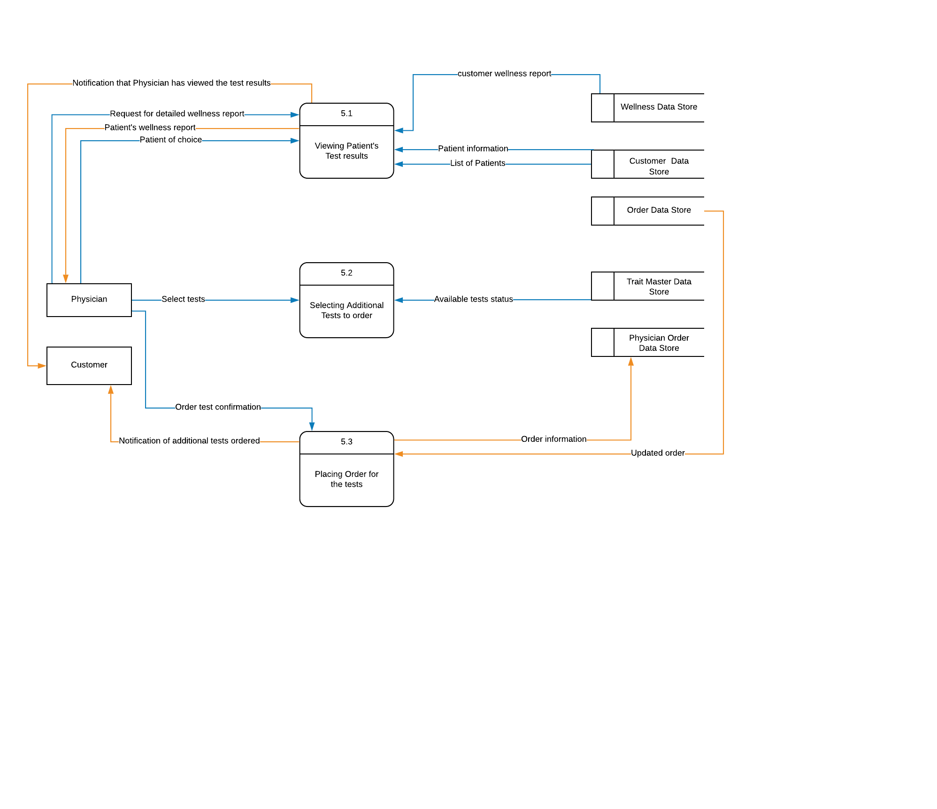

**Structure Chart**

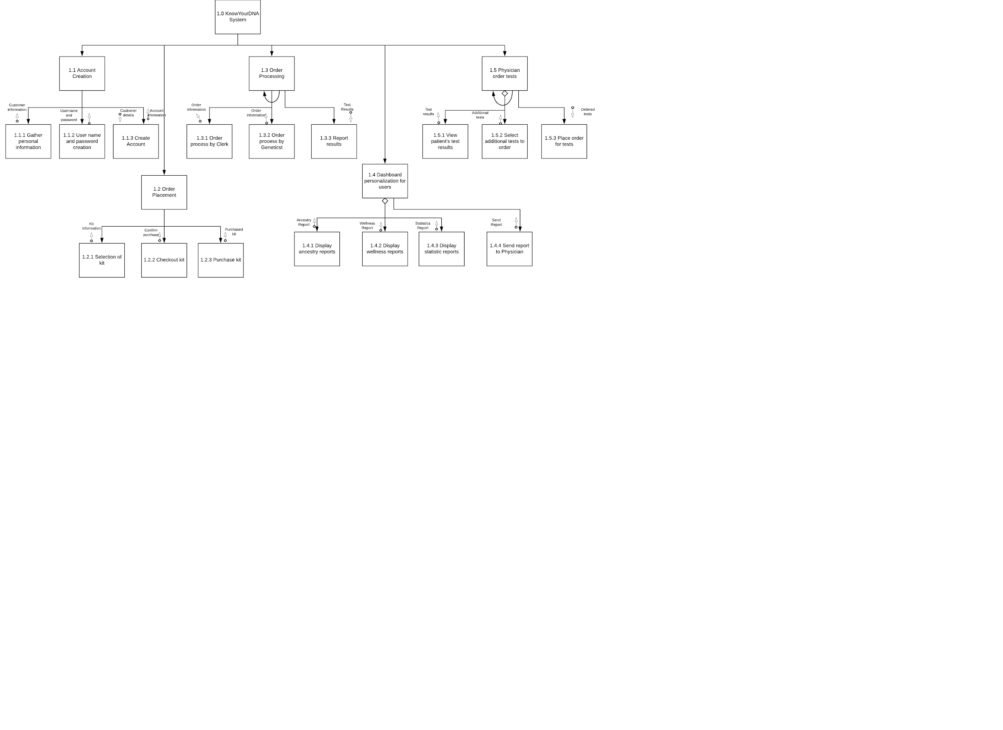

**Data Dictionary**

1. **Customer_Data_Store**

|  |  |  |  |
| --- | --- | --- | --- |
| **Field/Column Name** | **Data Type** | **Domain** | **Description** |
| Customer_ID | string | 5 | Unique customer ID identifying the customers |
| Customer_FirstName | string | 10-15 | Stores customers first name |
| Customer_LastName | string | 10-15 | Stores customer last name |
| Customer_Address | string | 30-40 | Stores customer address |
| Customer_ZipCode | char | 5 | Stores customer zip code |
| Customer_PhoneNumber | int | 10 | Stores customer phone number |
| Customer_EmailAddress | varchar | 10-15 | Stores customer email address |
| Created_Date | date | System-specific | The date the customer record was created |
| Last_Updated_Date | date | System-specific | The date the customer record was updated |

1. **Physician_Data_Store**

|  |  |  |  |
| --- | --- | --- | --- |
| **Field/Column Name** | **Data Type** | **Domain** | **Description** |
| Physician_ID | string | 5 | Unique physician ID |
| Physician_License_Number | string | 6 | Physician's unique medical license number |
| Physician_FirstName | string | 10-15 | Physician First Name |
| Physician_LastName | string | 10-15 | Physician Last Name |
| Physician_ZipCode | char | 5 | Physician zip code |
| Physician_PhoneNumber | int | 10 | Physician phone number |
| Physician_EmailAddress | varchar | 10-15 | Physician email address |
| Created_Date | date | System-specific | The date the physician record was created |
| Last_Updated_Date | date | System-specific | The date the physician record was updated |

1. **Item_Data_Store**

|  |  |  |  |
| --- | --- | --- | --- |
| **Field/Column Name** | **Data Type** | **Domain** | **Description** |
| Kit_ID | string | 5 | Unique registration kit number |
| Kit_Name | string | 20-25 | Registration kit name |
| Kit_Description | string | 100-150 | Registration kit description |
| Kit_Image | BLOB | png, jpeg | Registration kit image |
| Kit_Price | float | 2-3 | Registration kit selling price in float |
| Created_Date | date | System-specific | The date the item record was created |
| Last_Updated_Date | date | System-specific | The date the item record was updated |

1. **Order_Data_Store**

|  |  |  |  |
| --- | --- | --- | --- |
| **Field/Column Name** | **Data Type** | **Domain** | **Description** |
| Order_ID | string | 10 | Order of the tests placed by the customer |
| Order_Date | date | mm-dd-yyyy | Date on which order request was placed |
| Customer_ID | string | 5 | Unique customer ID identifying the customers |
| Kit_ID | string | 5 | Unique registration kit number |
| Cust_Ship_Address | string | 30-40 | Shipping address of the customer to collect his sample |
| Cust_Payment_Info | string | Debit, Credit | Payment information of the customer |
| Clerk_Employee_ID | string | 5 | Employee ID of the clerk who maintains the Order Data Store |
| Order_Tracking_ID | string | 10-12 | Tracking ID provided by UPS |
| Geneticist_Employee_ID | string | 5 | Employee ID of the geneticist |
| Physician_ID | string | 5 | Unique physician ID |
| Order_Comments | string | 100-120 | Comments provided by the clerk and geneticist |
| Order_Status | string | New, Assigned, In Progress, Hold, Completed | Current status of the order |
| Created_Date | date | System-specific | The date the order record was created |
| Last_Updated_Date | date | System-specific | The date the order record was updated |
| Last_Updated_By | string | 10-15 | Employee name who updates the order record |

1. **Traits_Data_Store**

|  |  |  |  |
| --- | --- | --- | --- |
| **Field/Column Name** | **Data Type** | **Domain** | **Description** |
| Trait_ID | string | 7 | Unique trait id |
| Trait_Type | string | Wellness,  Health, Ancestry | Store the categories of trait type |
| Trait_Description | string | 100-150 | Describes the characteristics of traits |
| Trait_Availability_Status | Boolean | Yes, No | Holds information regarding the availability of traits for testing |
| Trait_Included_Kit | Boolean | Yes, No | If trait included in the kit - yes, otherwise no |
| Created_Date | date | System-specific | The date the trait record was created |
| Last_Updated_Date | date | System-specific | The date the trait record was updated |

1. **Ancestry_Data_Store**

|  |  |  |  |
| --- | --- | --- | --- |
| **Field/Column Name** | **Data Type** | **Domain** | **Description** |
| Customer_ID | string | 5 | Unique customer ID identifying the customers |
| Order_ID | string | 10 | Order of the tests placed by the customer |
| Trait_ID | string | 7 | Unique trait id |
| Ancestry_Report | string | 200-250 | Holds information regarding ancestry test results of customer |
| Created_Date | date | System-specific | The date the ancestry record was created |
| Last_Updated_Date | date | System-specific | The date the ancestry record was updated |

1. **Statistics_Data_Store**

|  |  |  |  |
| --- | --- | --- | --- |
| **Field/Column Name** | **Data Type** | **Domain** | **Description** |
| Customer_ID | string | 5 | Unique customer ID identifying the customers |
| Order_ID | string | 10 | Order of the tests placed by the customer |
| Trait_ID | string | 7 | Unique trait id |
| Statistics_Report | string | 200-250 | Holds information regarding statistics of customer |
| Created_Date | date | System-specific | The date the statistics record was created |
| Last_Updated_Date | date | System-specific | The date the statistics record was updated |

1. **Wellness_Data_Store**

|  |  |  |  |
| --- | --- | --- | --- |
| **Field/Column Name** | **Data Type** | **Domain** | **Description** |
| Customer_ID | string | 5 | Unique customer ID identifying the customers |
| Order_ID | string | 10 | Order of the tests placed by the customer |
| Trait_ID | string | 7 | Unique trait id |
| Customer_Wellness_Report | string | 200-250 | Holds information regarding wellness report for the customer |
| Physician_Wellness_Report | string | 300-350 | Holds information regarding wellness report of the customer for the physician |
| Created_Date | date | System-specific | The date the wellness record was created |
| Last_Updated_Date | date | System-specific | The date the wellness record was updated |

1. **Physician_Order_Data_Store**

|  |  |  |  |
| --- | --- | --- | --- |
| **Field/Column Name** | **Data Type** | **Domain** | **Description** |
| Physician_ID | string | 5 | Unique customer ID identifying the customers |
| Customer_ID | string | 5 | Unique customer ID identifying the customers |
| Trait_ID | string | 7 | Unique trait id |
| Physician_Order_ID | string | 10 | Unique ID for the orders that are submitted by the physician |
| Created_Date | date | System-specific | The date the order record was created |
| Last_Updated_Date | date | System-specific | The date the order record was updated |

**UI Mockups**

**Landing Page 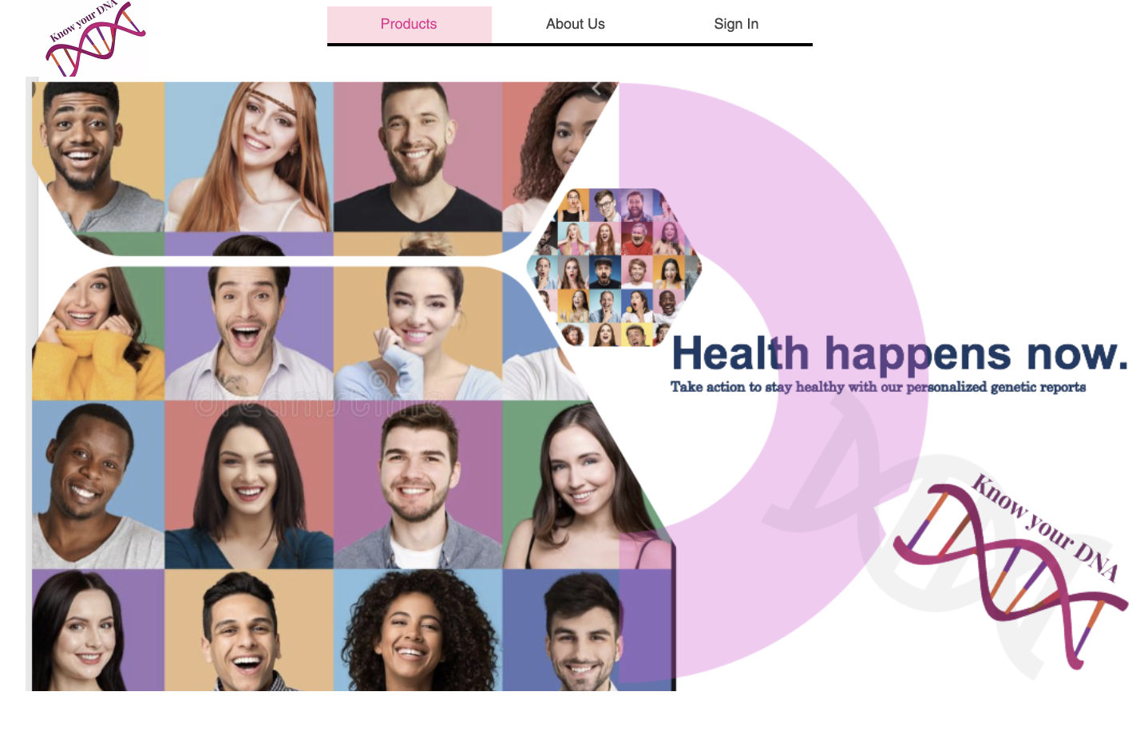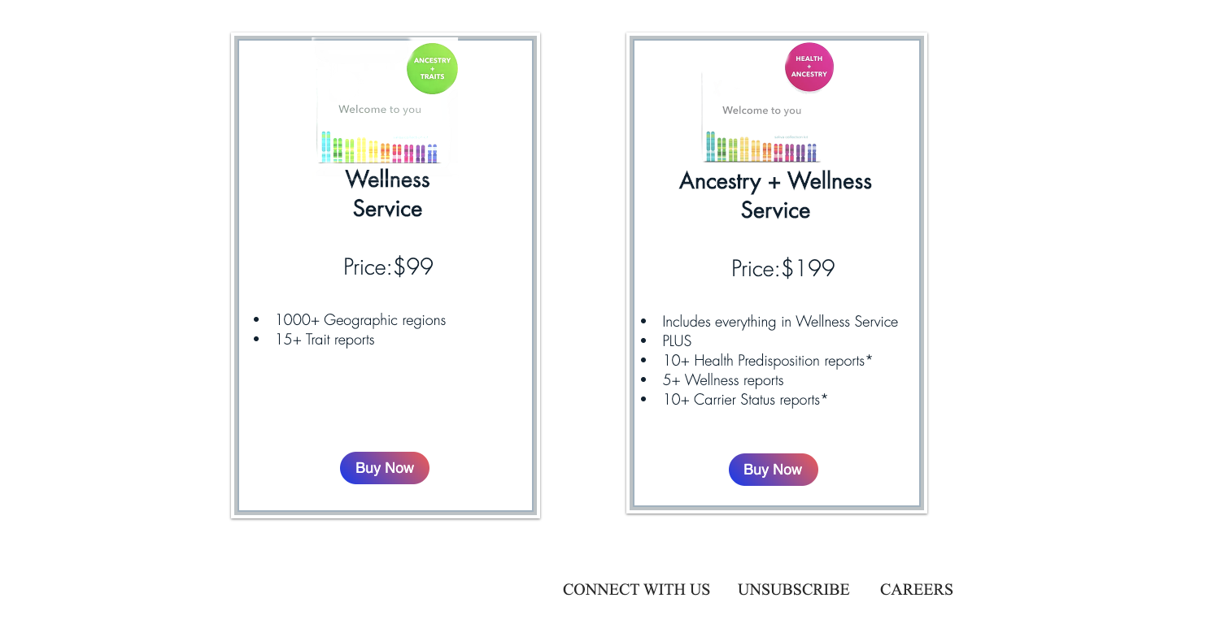Creating an account: Customer** 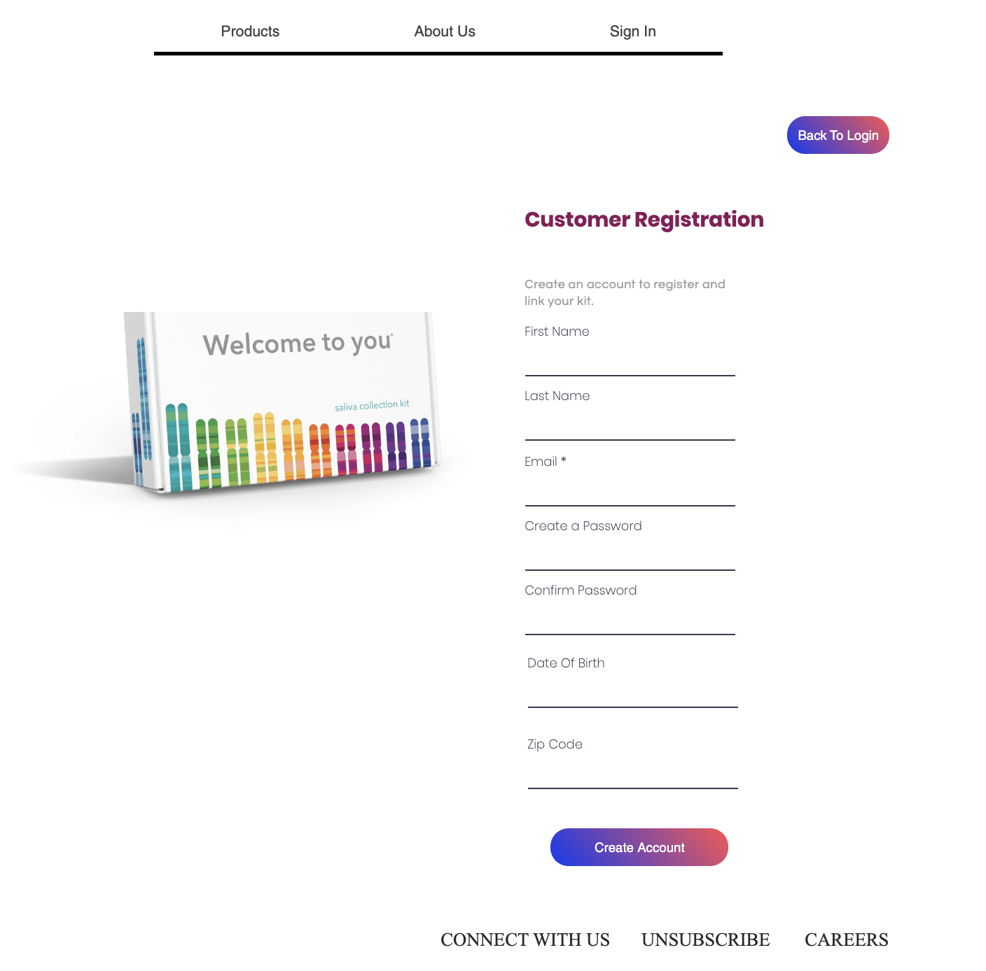

**Signing in: Customer**

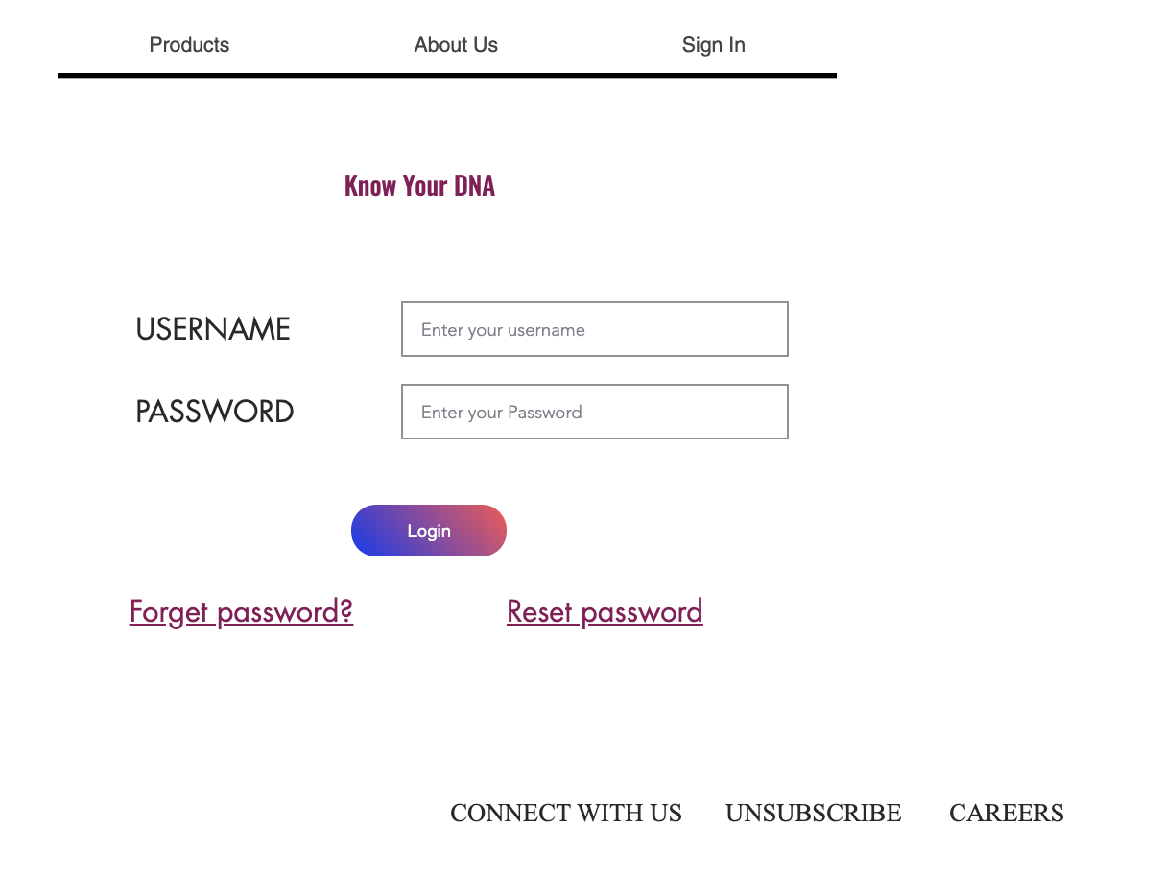

**Payments Page**

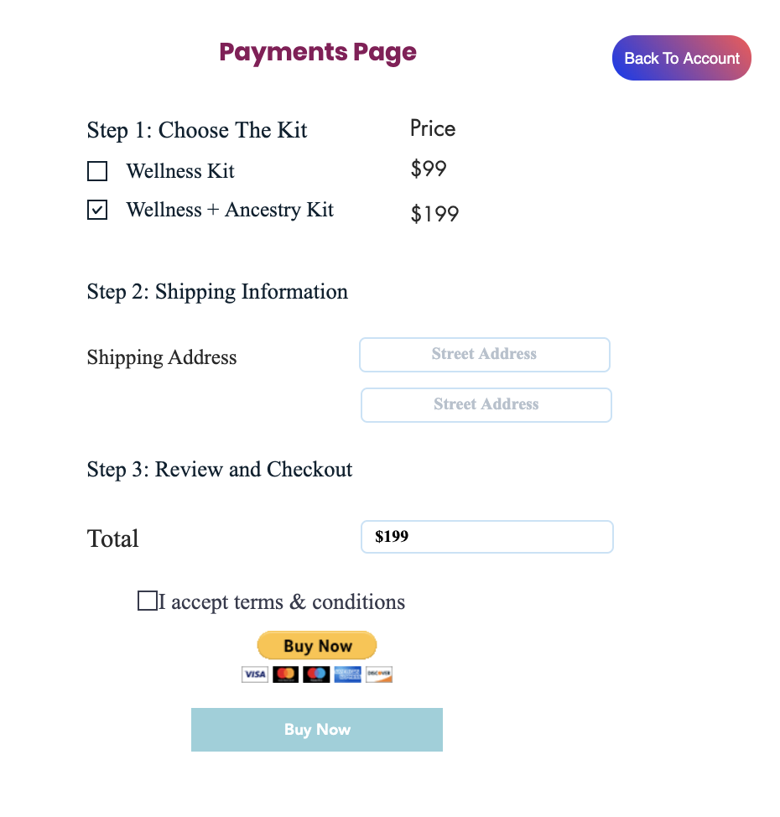

**Customer Dashboard**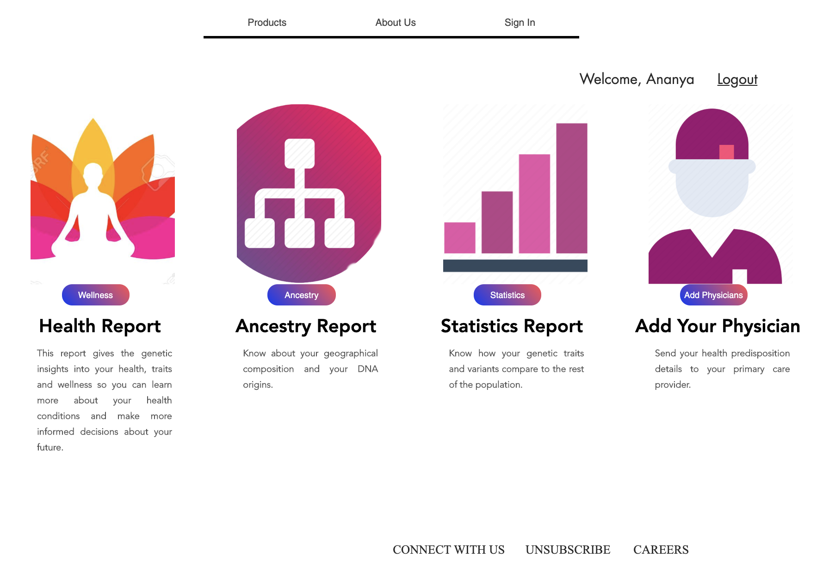

**Customer Health and Wellness Report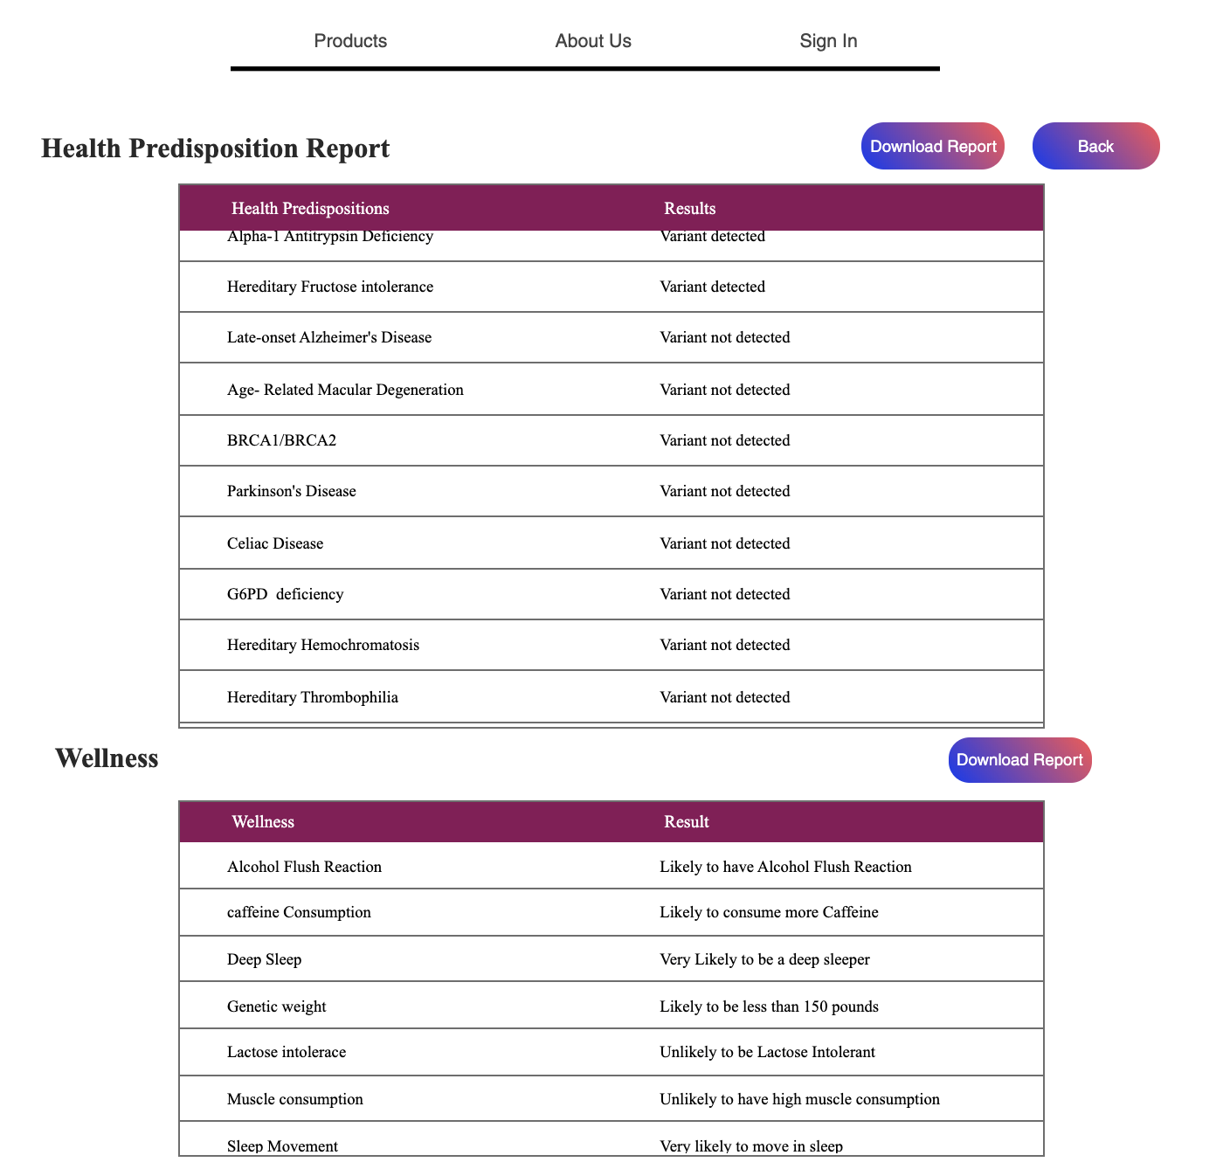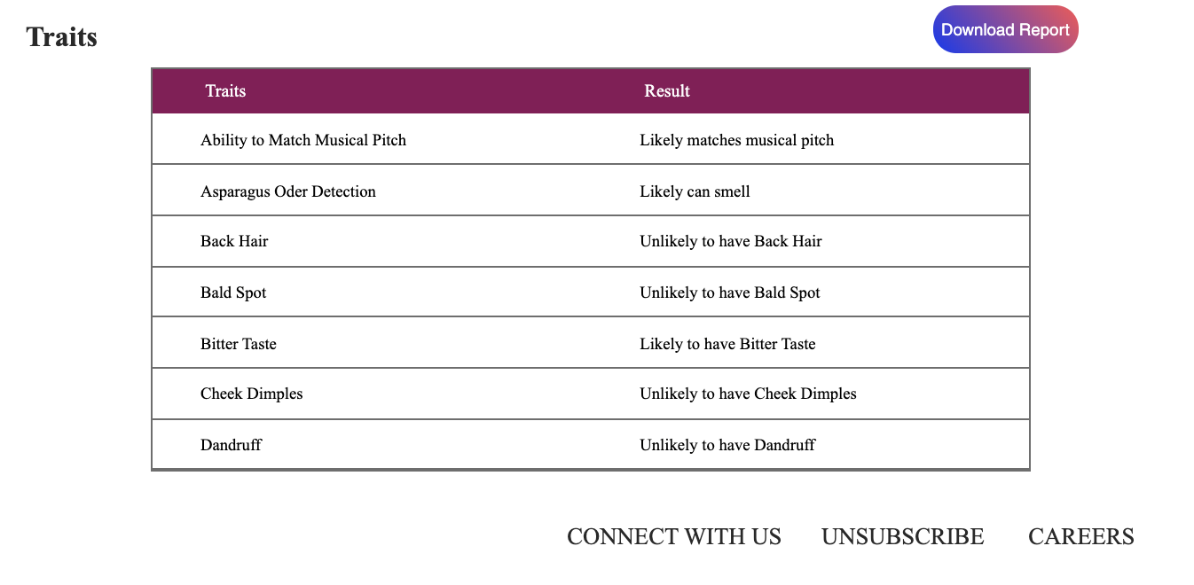Customer Ancestry Report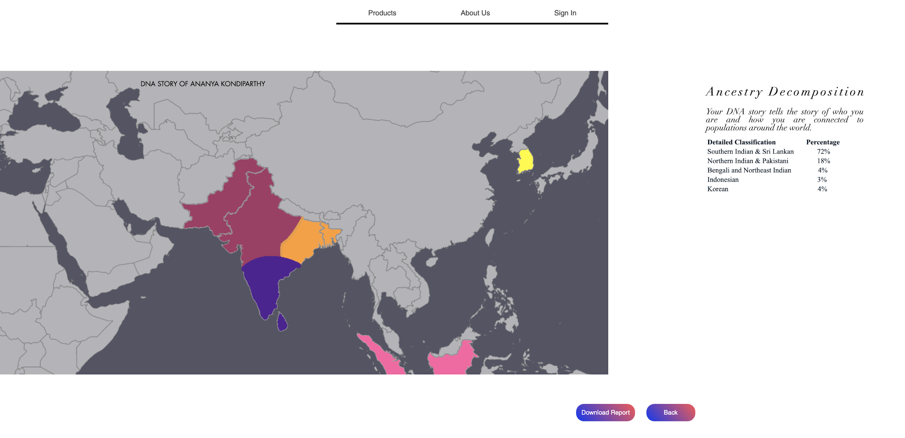Customer Statistics Report**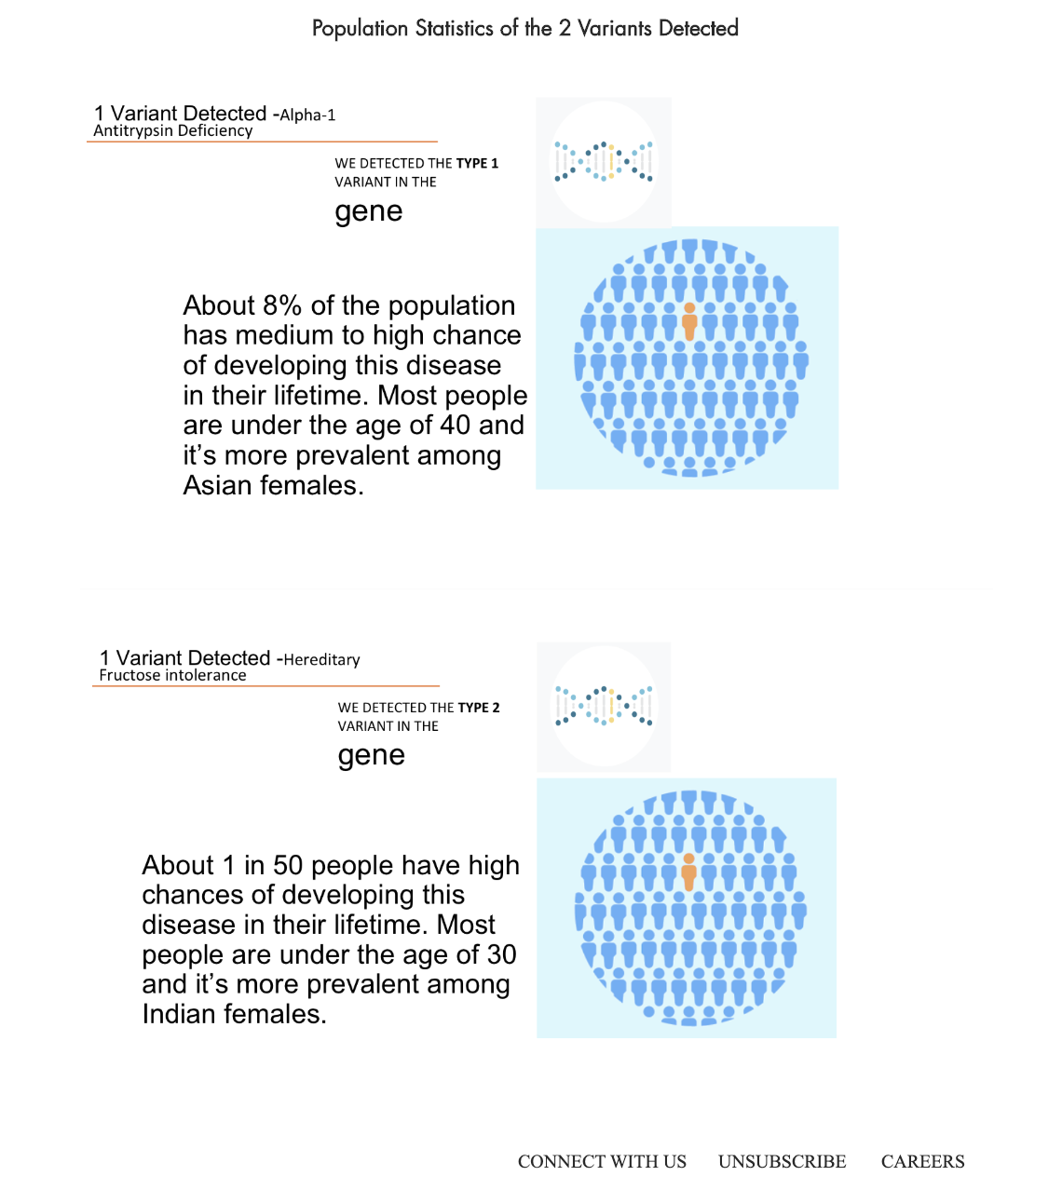

**Adding Physician to send the report:**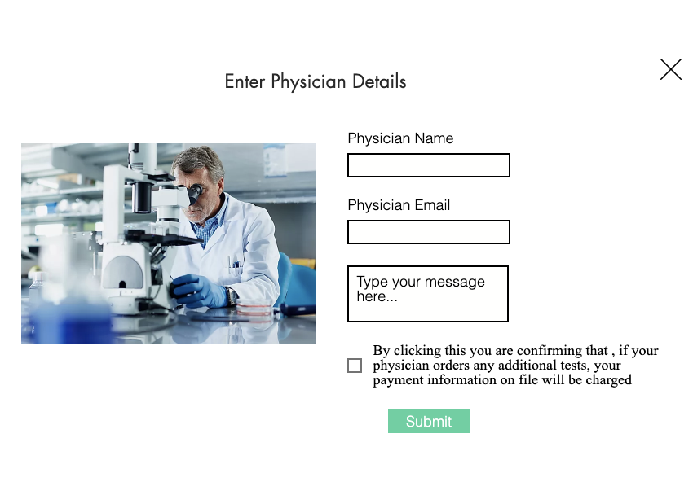

**Signing in: Physician** 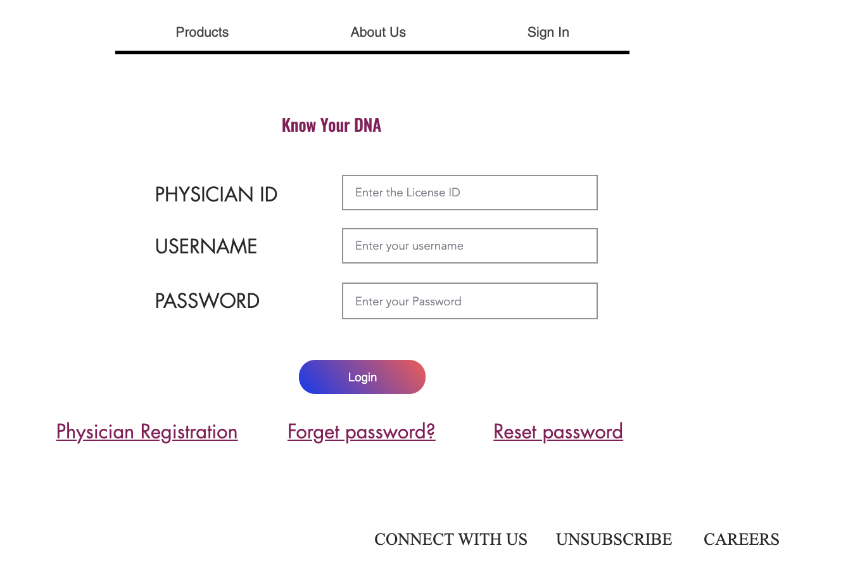

**Physician Dashboard**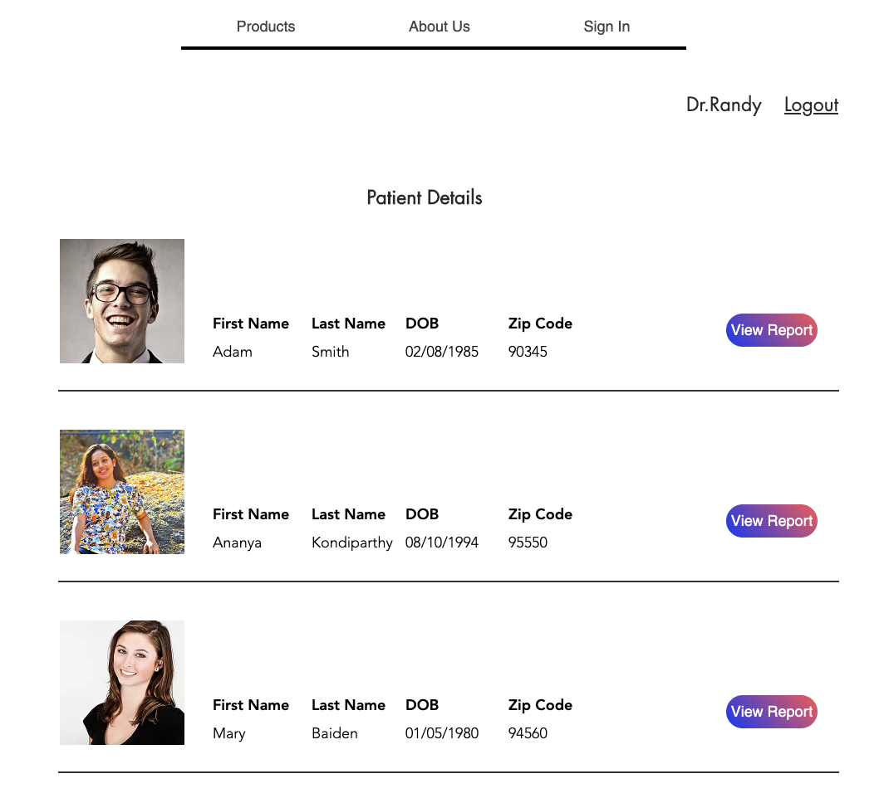

**Physicians’s view of the Customer Wellness Report 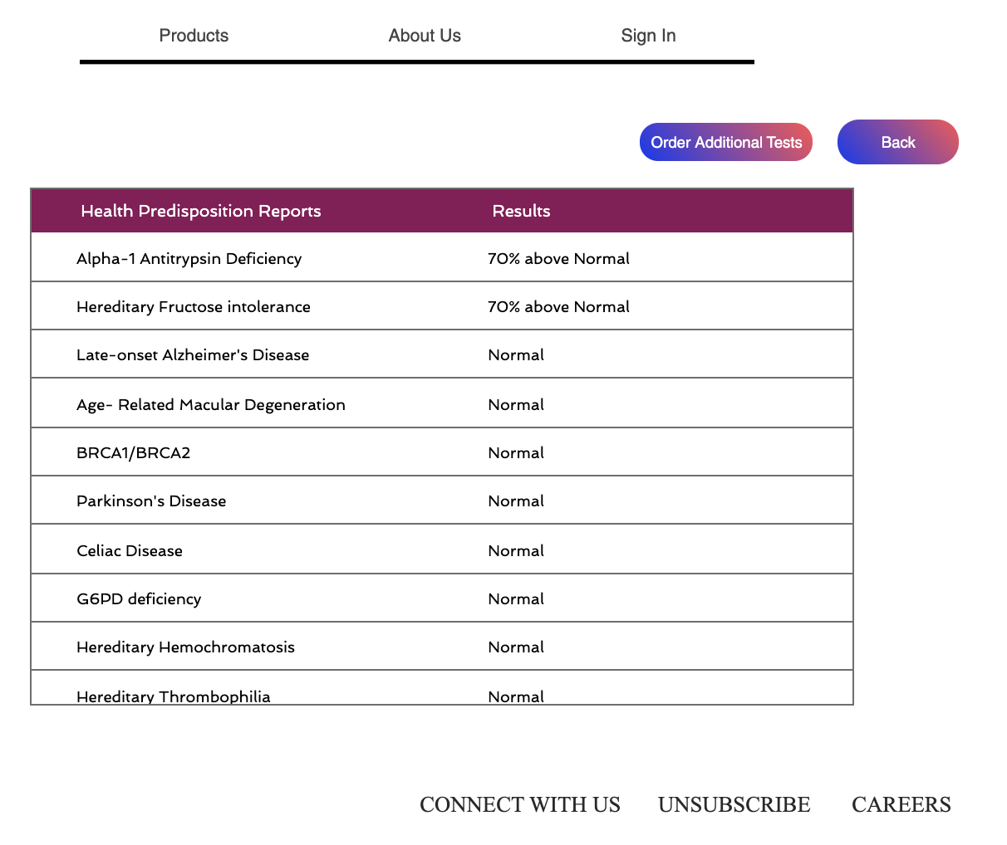Physician view to Order more tests**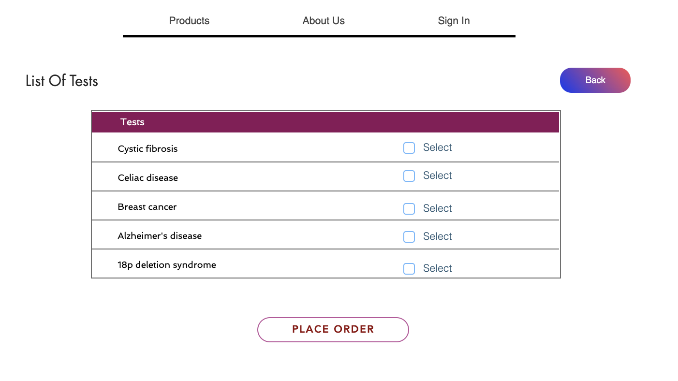

**Future Work**

Currently, our array of tests can inform patients and physician about their :

* carrier status of 25 inherited conditions and how their genetics can influence their chances of developing certain conditions,
* how their DNA influences 25 physical traits,
* how 7 genes play a role in their well- being and lifestyle choices, and
* where their DNA is from out of 600+ regions worldwide.

As a next step, on the wellness and health front, we would like to add 50 additional variant testing capability which would cover biomarkers for rare carcinomas and immunological diseases such as giant cell arthritis, where the patient’s disease progression might take years and goes undiagnosed eventually leading to loss of vision or worse symptoms. Hence in such cases, early detection is crucial.

On the ancestry front, we would also like to give customers an option to connect with people who share DNA with them through the ‘DNA Relative Finder’ feature. Customers can also create family trees with the ‘Tree Builder’ feature. In addition to this, customers will be able to trace parts of their ancestry to a specific group of individuals from 1,000+ years ago and learn about which civilizations their forefather descended from.

We also plan aiding the physician help their patients better, and hence plan on adding 30 additional biomarker tests that the physicians can order. This helps keep the customer’s test and genetic health records on one single portal which would facilitate easy access for the customers and their physicians. We believe that having a comprehensive and complete understanding of the customer’s biomarker profile will prevent the progression of some serious conditions.

By 2023, we plan to partner with several research facilities that conduct genetic research. Customers can opt into our research program that can help drive scientific and medical discoveries. This kind of genetic research gives everyday people the opportunity to make a difference. Researchers would link the customer’s genetic data to study topics from ancestry, to traits, to disease which can accelerate research and would help answer some scientific mysteries and solve for unmet medical needs.

**Conclusion**

The Genome testing project was conceptualized with the intention to help customers gain knowledge about their genetic predispositions and ancestry. Currently, KnowYourDNA has 2 products: Wellness and Ancestry and Wellness kits. Customers can send samples of their DNA through a specimen that is then sequenced using standard procedures and then matched with a predefined set of patterns and ancestry sequences. The system also makes customers aware of how their genetic makeup compared to the rest of the world through epidemiological statistics reports. In addition to this, customers can also send their reports to their physician who can better educate on what these results mean and how it would affect them. If their physicians feel like additional tests are required to gain a better understanding of the results presented they can choose from a list of available additional tests as well.

Currently, KnowYourDNA has carrier statuses of 25 inherited conditions, 25 physical traits, 7 wellness genes, and 600+ regions worldwide in their test profile. We plan on bringing in new functionalities and capabilities to our products that will continue to improve health outcomes and promote better understanding of the human genome.